|  |  |  |
| --- | --- | --- |
|  |  |  |

Resume Of

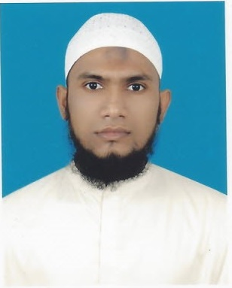

Md. Tofayel Ahmed

Mailing Address :

**House No: 236/A, South Kutubkhali, P.O: Donia**

**P.S: Jatrabari, Dhaka- 1236**

**Mobile : 01918338997**

**E-mail :** [**ahmedtofa95@yahoo.com**](mailto:ahmedtofa95@yahoo.com)

**LinkedIn : https://www.linkedin.com/in/md-tofayel-ahmed-170341145**

Career Objective:

To obtain a challenging and competitive career in Software Engineering or Web Development sector in any reputed IT organization through my educational background, skills and experience.

**Professional Courses in Computer Science (. NET FRAMEWORK)**

|  |  |  |  |
| --- | --- | --- | --- |
| **Course Name** | **Institution** | **Duration** | **Year** |
| Enterprise System Analysis  And Design – C# .Net | IDB-BISEW IT Scholarship Project | 1 Year | 2016 |
| Web Application Development- Dot Net | Govt. SEIP Project on BITM. | Three Months | 2017 |

Academic Details

|  |  |  |  |  |
| --- | --- | --- | --- | --- |
| **Exam Title** | **Subject** | **Institute** | **Result** | **Year of Passing** |
| M.Sc. | Mathematics | KABI NAZRUL GOVT. COLLEGE, under National University | Second  Class | 2013 |
| B.Sc. | Mathematics | GOVT. SHAHID SUHRAWARDY COLLEGE, under National University | Second  Class | 2012 |
| H.S.C | Science | University Laboratory College. | 4.40 | 2008 |
| S.S.C | Science | A.K. High School and College | 4.56 | 2006 |

|  |
| --- |
| Technical and computer skill |

|  |  |
| --- | --- |
| **Programming Language** | C# |
| **Database** | Microsoft SQL Server 2012, MS Access |
| **System Analysis & Design** | Object Oriented Systems Analysis and Design using UML |
| **Software Modeling** | Microsoft Office Visio Professional 2010 |
| **Markup Languages** | HTML5, XML |
| **Web Layout and Design** | CSS3 |
| **Scripting Language** | JavaScript, jQuery, Ajax, AngularJS, node.js. |
| **.NET Technologies** | ASP.NET 5.0, MVC 5, MVC 6, ADO.NET 4.0, entity framework 4.5 and 4.6 |
| **Development Tools** | Microsoft Visual Studio 2013, SQL Server Management Studio, Notepad |
| **Computer Fundamentals** | MS Office 2007/2010 (MS Word, MS Excel, MS Power Point, Outlook Express). Internet and Communication |

**Microsoft Certification Exams Completed Successfully**

|  |  |  |  |
| --- | --- | --- | --- |
| **Exam ID** | **Microsoft Certification ID** | **Description** | **Status** |
| 480 | 14049647 | Programming in HTML5 with JavaScript and CSS3 | Microsoft Certified |

*** To verify certification: <http://www.mycertprofile.com/Profile/1711283492>

Language skill : Proficiency both on Bangla and Modern English with IELTS brand score 6.0

**Project Summary on .Net Framework :**

|  |  |  |  |
| --- | --- | --- | --- |
| Project Name | Live Url | Git Hub Repository | Youtube Link: |
| University Course and Result Management System. | <http://bitm-ums.azurewebsites.net> | **https://github.com/Tofayel95/UCAMS/tree/FinalBranch** | **https://youtu.be/n_Q3ZrmpNb4** |
| Diagnostic Center Management System. | **http://diagnosticbillmanagementapp.azurewebsites.net** | **https://github.com/Tofayel95/DCMS_Project.git** | <https://youtu.be/Y2f7xr-Bqqo> |

Personal information:

Father’S Name : Md. Abdul Jalil

Mother’S Name : Khadija Jesmin

Date of birth : 01-01-1990

Village Address : Shibpur, Thana : Devidwar, Dist : Comilla.

Nationality : Bangladeshi

Religion : Islam(Sunni)

Blood Group : O+

Marital Status : Single

References:

1. Md. Zahirul Alom Timoon 2. Md. Tayabur **Rahman Masud**

Lead Trainer of BITM. Trainer of BITM and Senior

CEO of Nerd Castle Ltd. Software Engineer of

Contact : [ceo@nerdcastlebd.com](mailto:ceo@nerdcastlebd.com) Nerd Castle Ltd.

Contact : 01617962783

**Declaration**

* As a security clearance I have no criminal records in any civil court or in any police station.
* I am undersigned, hereby declare that I will be responsible for any wrong information provided above.

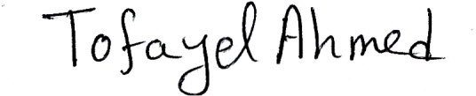 **Signature & Date:**